Troubles and assistance in crafting workshops

The following extract is taken from a pottery studio session with five students present. We’ll be focussing on two students in this extract. Pierre (the instructor), Nicola and Ashley (the students) have been talking about the clutter in Nicola’s house and how she needs to clear it to make space for her pottery work. Pierre has asked Nicola if she collects wheels and kilns, to which she provides a negative response.

The extract has been transcribed using Jeffersonian transcription conventions. Gaze has been transcribed using Mondadan conventions, although no other forms of embodied conduct have been included. All names and locations have been pseudonymised, and audio related to the place names mentioned in lines 7 and 8 has been omitted.

In this extract, I’m interested in the ways that students and instructors coordinate use of tools and materials in the classroom.

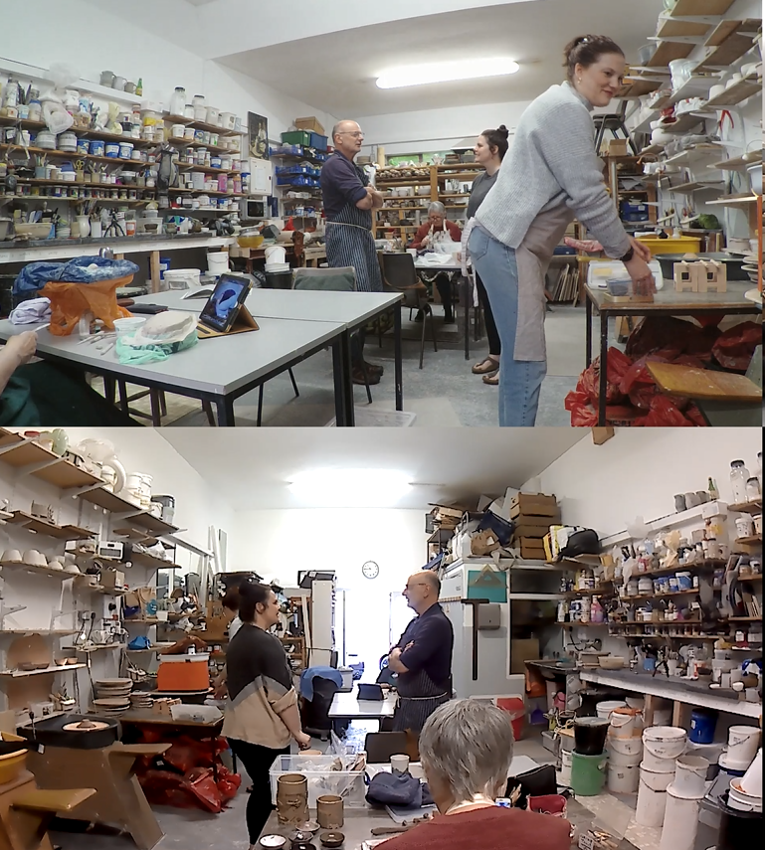
Pierre
Nicola
Ashley

PS0706 0:25:50

01 NIC: where you collect *+ k↑iln*s:?
>>gz to PIE-->
ash *gz left*gz to PIE-->
pie +gz to NIC-->
02 PIE: +whe(h)e(h)ls.
+gz to ASH-->
03 NIC: *or %+whe[els?
%gz to ASH-->
ash *gz left-->
pie +gz left-->
04 PIE: [OR used [*to.
05 ASH: [*am %I+ okay to go *on that one.
*gz to PIE--------*gz left-->
ash -->%gz right-->
pie -->+gz to NIC-->
06 *[is that %okay.]
07 PIE: p*[ i t y % a h ] well I left +%e*rm mh +Mea%dow’s
-->+gz up-----+gz to NIC-->
nic -->%gz to PIE-----------%gz to ASH---%gz to PIE-->
ash *gz to PIE------------------------*
08 Park in Birmingham I ha- I think I had e:rm::
09 (0.6) .hh e::h (0.2) something like f:ourteen
10 wheels and (0.3) twelve kilns.
11 (0.7)
12 PIE: ( ) the:re
13 (0.2)
14 NIC: [ SO ] you’ve got [twelve kilns ]=
15 PIE: [you-] [you could now]=
16 PIE: =they’ve all gone [ now ]
17 NIC: [I was .hh g(h)](h)o(h)nna
18 sa[y %huahuahua (they’re gonna %be) outs]%ide your=
19 PIE: [ % okay ( ) ]
nic -->%gz to ASH----------------%gz fwd---%gz down-->
20 NIC: =house+
pie -->+gz to ASH-->
21 ASH: [(ju(h)(h)st the(h)(h)re it’s like if we come]=
22 NIC: [ (kn%ock on your door) ]
-->%gz to PIE-->
23 PIE: [ ( ) ]
24 ASH: =%(OUTSIDE) YOUR HOU%SE
nic -->%gz to ASH---------%gz to PIE-->
25 NIC: [ .HHHHH ]
26 PIE: [(I) put them all] on ebay.
27 NIC: oh did ya.
28 PIE: [ and erm ]
29 NIC: [and did you] sell them.
30 (0.6)
31 PIE: ye:ah.
32 (0.1)%(0.2)
nic -->%gz down-->
33 PIE: the- (.) the- (.) %>what do yo- what you doing.<
nic -->%gz left-->
34 ASH: >I’m gonna put it on there< if that’s (alright)
nic -->%gz left-->
35 I’m wanna go on this wheel.
36 PIE: oh you’re gonna +throw on there.+
pie -->+gz left--------+gz to ASH-->
37 (0.4)
38 ASH: yeah because I wanna ba:ts[+::]
39 PIE: [+oh] well we’ll
pie -->+gz fwd-->
40 we’ll [ just go on +here, ]
pie -->+gz to ASH-->
41 NIC: [well do you want me to move.]
42 (0.5)
43 PIE: +we’ll just- (.) t- +turn on there.
->+gz left------------+gz to ASH-->
44 PIE: +cos it’s better to tu+rn on a metal.
->+gz left--------------+gz to ASH-->
45 NIC: (>t[rust me<) +I’ll j]ust move
46 ASH: [ o h y +e a h ]. is that %alright.=
pie -->+gz fwd-->
nic -->%gz fwd-->
47 NIC: =yeah.+
pie -->+
48 (1.3)
49 NIC: I’ve just made a bit of a mess though.
50 (0.3)
51 NIC: e::h ohf:% shall I [finish this one.]
-->%gz left-->gz to ASH-->
52 ASH: [ yeah it is ] better to stick it-
53 on=oh yeah% you might [ as well. ]
nic -->%gz left-->
54 NIC: [I’ll finish] that [one
55 ASH: [yeah. finish
56 that one.%
nic -->%gz right-->>
57 NIC: I’ll finish that one and then I’ll
58 s[(ort of move it) over ]
59 ASH: [I’ve got some bits to do first] anyway.

A pottery bat is a flat disc that attaches to a pottery wheel and allows for easy removal of the pottery, reducing the chances of distortion.

